**Milestone 1: Graph Creation - 12hr**

This deals with the creation of a suitable graph prior to it being ‘plotted’.

It will need to be set up so that a user can set the range of X and Y axes, this will also need to accommodate negative values in the Y axis for things such as ‘drugs’ whose effect may be to depress a vital.

Given the chosen range this will then need to be divided up so that numbering along each axis can be easily read such as (in terms of X being time this will also need to suitably accommodate seconds, minutes and potentially hours) ideally with the use of three weights of line being introduced (as per a ‘traditional’ graph paper with the heaviest lines being used for 10s, medium for 5s and lightest for single units (see Fig 1: below – however it should also be noted that these lines are a little too dark however it also clearly shows what is hoped for). Clearly each point along the axis will not require numbering so a system that provides suitable numbering is also required. See Fig 2 for an example of how axes might be marked, however what needs to be kept in mind is that the X axis deals with time so we also have to deal with changes from seconds to minutes and potentially hours.



Fig 1

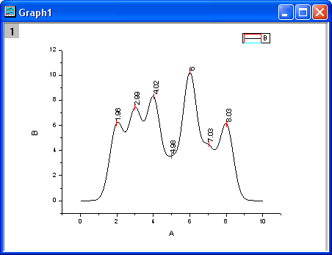

**Milestone 2: Graph Plotting – 16hr**

**(of which 8hr)**

At this point straight line plotting from point to point is acceptable – curves being potential additional work. Users will need a means to add, move and remove points (this will also include these activities on a graph that already spans the X axis). Points will need to be kept within the graph. We discussed the notion that if there are a series of points and one is grabbed and the user attempts to move it to a point where its X value is less than another the user should be prevented from doing so. One issue that might occur as a result of this is that two points might become super imposed and this also needs to be prevented (perhaps there is a warning about amalgamating two points into a single point?).

Vital graphs will require lower and upper limits for the simulation – so that if these are exceeded the ‘simulation’ will cease.

**(of which 8hr)**

Line rendering and input/display box for point parameters (displayed adjacent to point in such a way that is updated as the point is moved).

**Milestone 3: Scenario Creation – 12hr**

One thing that was forgotten in our discussion was the notion of saving and loading scenario’s. I suspect this has not been included in this section so I have added another milestone following this with a suggested time.

The tutor needs to be able to create (and edit) a scenario/scene for student use, this should have a name. I would suggest that this begins with its length which will then automatically set up (or edit) the X axis of vitals. For vitals (and other things such as method of drug administration) we could use enums – but it should also be possible for user defined vitals to be added. Drugs will also have a user set name and dose. Prior to the creation of a drug’s graph the user will be required select the vital (which might also include on that is user defined) it will effect (it should be noted that in terms of the next milestone users should be able to save ‘drugs’ as well as ‘scenarios’ so that they can reuse them in another scenario). This should all be set up in such a way that it can be set up restrict access so that only ‘tutors’ can create scenarios.

**Milestone 4: Saving and Loading – 16hr**

Saving and loading functions should be provided for scenarios and drugs. This can be written in XML

**Milestone 5: Graph Superimposition and Runtime Functionality – 16hr**

**Graph Superimposition (of which 8hr)**

Given that a drug will have a vital it will effect there should be an option to see its effect on a vital at a particular point in time. This should be done by superimposing a drug on a vital graph in such a way that the user can slide the drug graph up and down the timeline. This should result in three lines – the original graphs for the vital and drug – and then a third which is the effect of the drug on the vital over the ‘lifetime’ of the drug.

**Runtime Functionality (of which 8hr)**

The system needs to be able to run in real time for the students who will be using the system

**Additional Work Yet to be Discussed**

Menu/interface for student users to ‘play’ scenarios.